Vasario 8 dienos pamoka
Kaip atsirado kompiuteriai?
https://www.youtube.com/watch?v=rE9Jua3iSk4

Computers
Do you know anything about the history of the computer?
Do you own a computer? What do you use it for?
Think about smart phones, like the iPhone. Do you consider them computers? Why or why not?
Do you think the desktop computer is going to become less popular in the future? If so, what will replace it?
Computers are starting to be built into new houses and apartments. Would you like a computer to control your house for you?
Do you think the invention and rise of computers has been a good thing or a bad thing? Why?
Talk about the first computer you ever used.
What will be the future of computers?
Do you think people rely too much on computers?

Vasario 9 dienos pamoka
Saugus internete
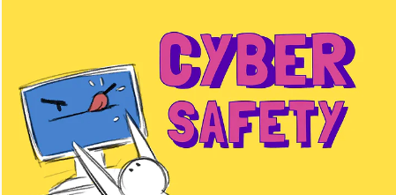

https://www.youtube.com/watch?v=yrln8nyVBLU

The increasing popularity of social networking sites and mobile phone texting have presented society with problems in how to protect children online. More and more youngsters are becoming victims of Internet predators and bullies. Parents are finding it more difficult to ensure their kids are safe online. Gone are the days when Mum and Dad could keep an eye on their child’s surfing with parental controls on the family computer. Today’s new mobile and networked world poses new and dangerous threats to online kids. Two recent initiatives aim to teach children about cyber-safety. Internet safety will soon be taught in UAE schools, while in Indiana, USA, parents will attend an Internet Social Networking conference.
The UAE has launched a nationwide programme aimed at educating students on how to use the Internet safely and avoid suspicious websites. Spokesman Jay Bavisi said: “Advances in instant communication media, including the likes of Twitter, Facebook, and other instant messaging services, drive the very fabric of our modern society. Parents, siblings, teachers and children alike will need to understand the dangers the connected world presents.” The Indiana conference will explore topics like cyber-bullying, sexting and online child exploitation. Local attorney Steven DeBrota said: “The number one way to keep a kid safe is for them to be skeptical. If they do not believe automatically what people tell them, they will be safer.”

CHAT: In pairs / groups, decide which of these topics or words from the article are most interesting and which are most boring.
popularity / mobile phones / protecting children / threats / cyber-safety / conferences / programmes / suspicious websites / communication / messaging / sexting / skeptical
INTERNET SAFETY: Complete this table with your partner(s). Change partners and share what you wrote. Change and share again.
Dangers | How big a danger? | How to deal with it/them?
Identity theft
Cyber-bullying
Phishing
Sexting
Viruses
Sexual predators
STAYING SAFE: What are the best ways for kids to stay safe online? Rank these and share your rankings with your partner. Put the safest at the top. Change partners and share your rankings again.
- Text/chat with people they know  - Tell parents where they’re surfing  - Use anti-virus software  - Keeping personal details secret | - Maximum privacy settings on facebook  - Using child-friendly sites only  - No sharing of photos  - Always be skeptical of everything

