Kovo 1 dienos pamoka

The beauty of America

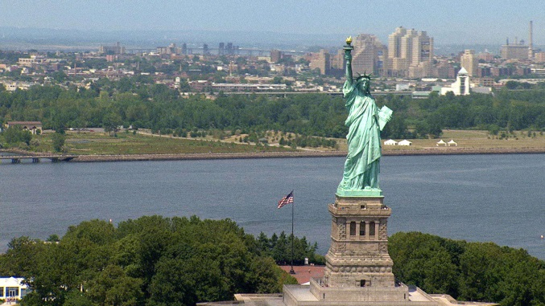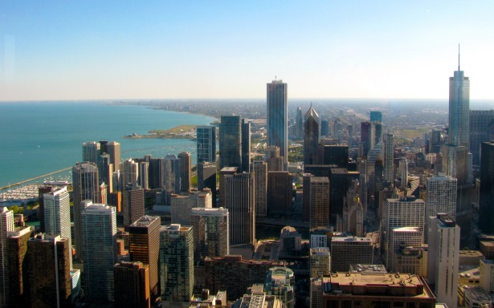

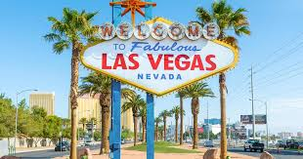

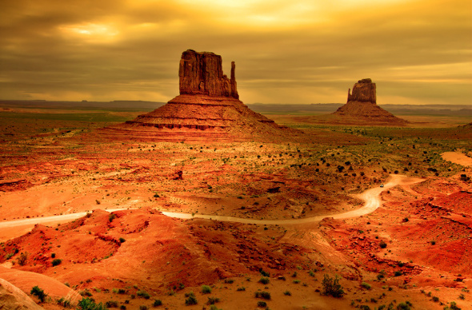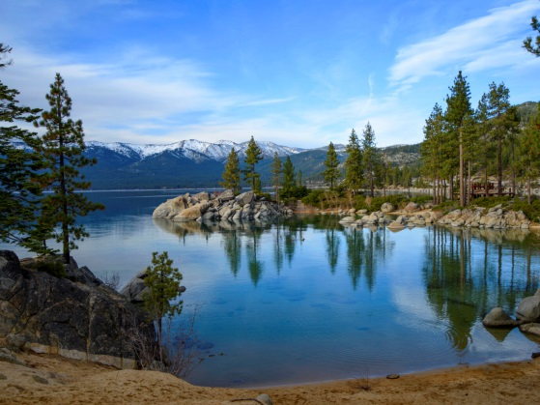

<https://lingua.com/english/reading/los-angeles/>

<https://lingua.com/english/reading/miami/>

<https://lingua.com/english/reading/chicago/>

<https://lingua.com/english/reading/san-francisco/>

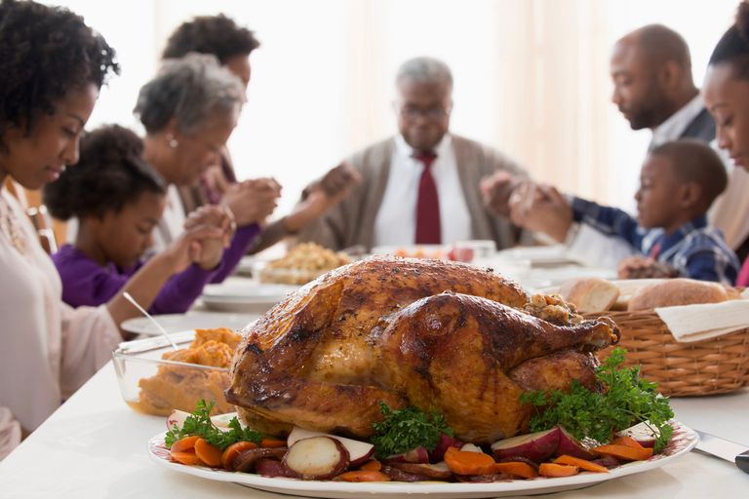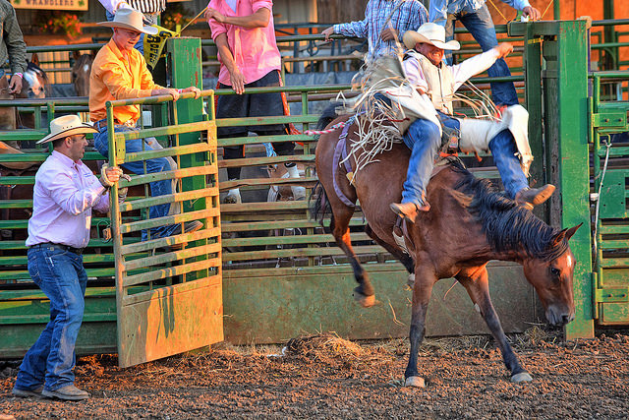

Kovo 2 dienos pamoka

**The most fascinating traditions in the USA**

<https://www.youtube.com/watch?v=77hFFKFOqmM>

What about American folk music?:)

<https://www.youtube.com/watch?v=Lvz6dcq80oU>

Let‘s sing along:

<https://www.youtube.com/watch?v=97S75R3_zRM>

Oh, My Darling Clementine

Oh my darling, oh my darling  
Oh my darling, Clementine  
You were lost and gone forever  
Dreadful sorrow, Clementine

In a cavern, in a canyon  
Excavating for a mine  
Dwelt a miner forty-niner  
And his daughter, Clementine

Yes I loved her, how I loved her  
Though her shoes were number nine  
Herring boxes, without topses  
Sandals were for Clementine

Oh my darling, oh my darling  
Oh my darling, Clementine  
You were lost and gone forever  
Dreadful sorrow, Clementine

Drove the horses to the water  
Every morning just at nine  
Hit her foot against a splinter  
Fell into the foaming brine

Ruby lips above the…

Oh my darling, oh my darling  
Oh my darling, Clementine  
You were lost and gone forever  
Dreadful sorrow, Clementine

You are lost and gone forever  
Dreadful sorrow, Clementine