Balandžio 26 dienos pamoka
Healthy lifestyle from the early age.....
How about compulsory cooking classes???
We are learning to discuss the pros and cons
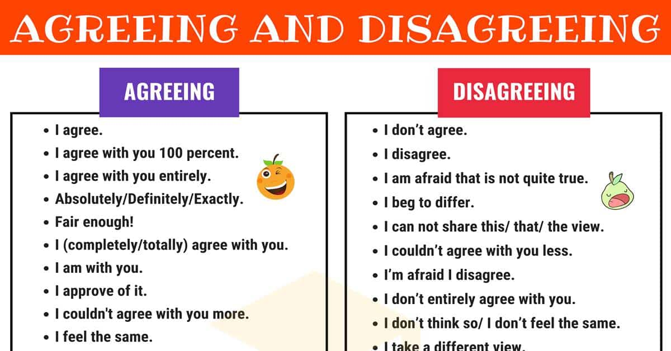

Balandžio 27 dienos pamoka
US, British or Australian English- how not to get confused
https://www.youtube.com/watch?v=66aG5P0kQpU
