Balandžio 15 dienos pamoka
Nanotechnologijos- džiaugsmas ar siaubas?
Nanotechnologies- should we be cautious?
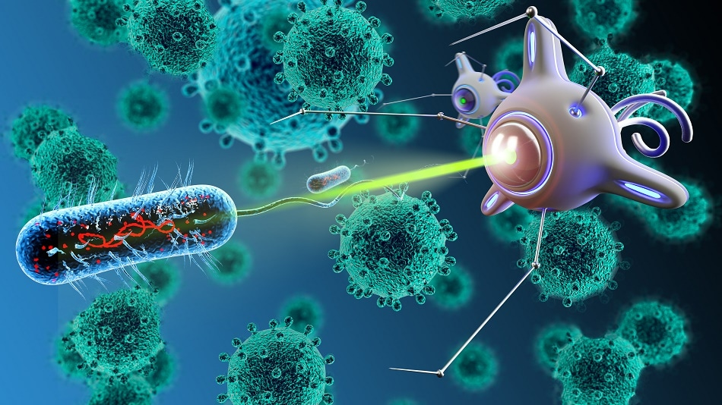
What is nanotechnology?
https://www.youtube.com/watch?v=dQhhcgn8YZo
Nanofoods
https://www.youtube.com/watch?v=cDUv3hUQ2C8
Nanotechnologies in medicine
https://www.youtube.com/watch?v=dn2UjBIsrcI
LET‘S CHECK WHAT WE‘VE LEARNT
https://quizlet.com/125072605/flashcards

Balandžio 16 dienos pamoka
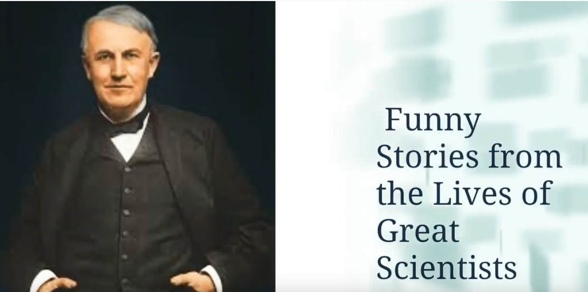

https://www.youtube.com/watch?v=9PmFVgXZQX8
https://www.youtube.com/watch?v=sxbhuMZZdMo
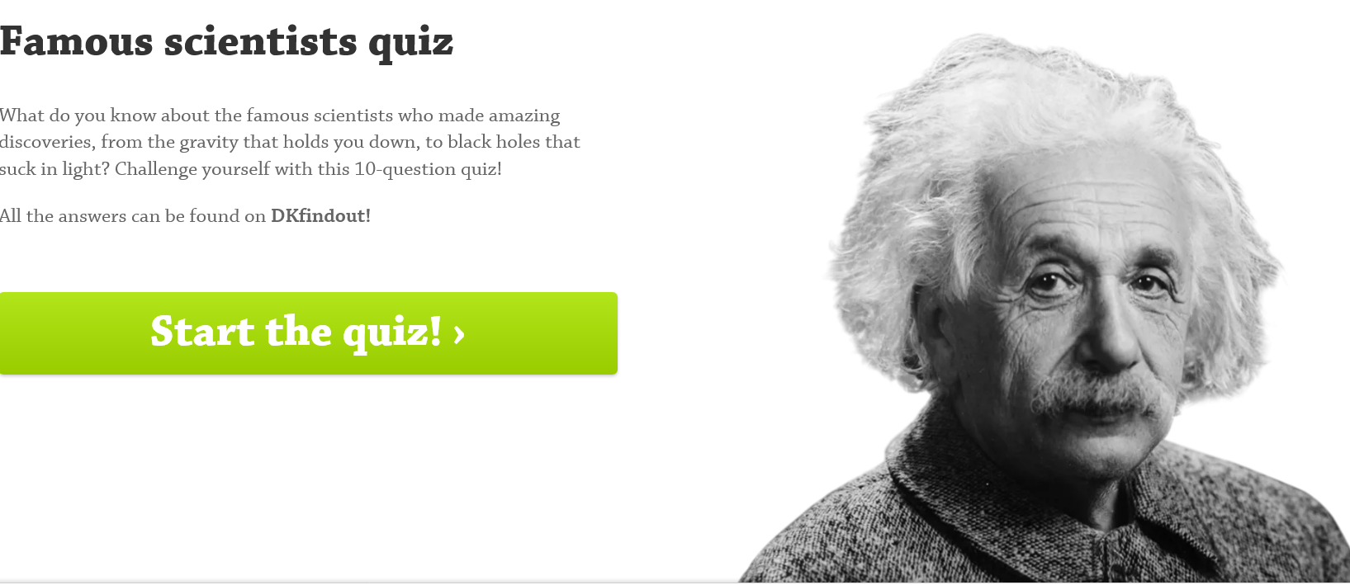
https://www.dkfindout.com/us/quiz/science/famous-scientists-quiz/

