Balandžio 19 dienos pamoka
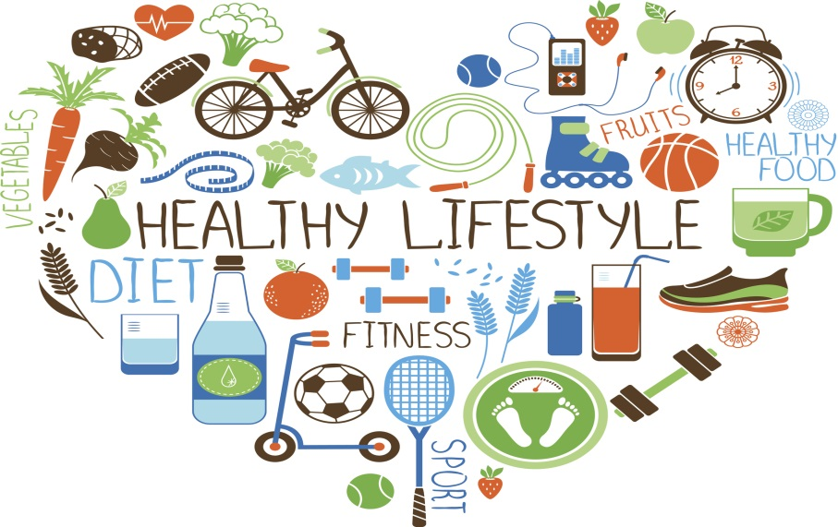
TIPS FOR STARTING A HEALTHY LIFESTYLE
https://www.englishwithjo.com/english-conversation-health/#more-870
- Do you already follow any of the recommendations provided in the video?
- Which one do you think is the easiest to do?
- Which one do you think is the hardest?
Conversation questions about health
- What are some things people can do to keep healthy?
- What are the most damaging things to people’s health?
- Is it possible to have a healthy life style in the modern world?
- What are the benefits of a healthy life style?
- What do you think are currently the most important health care issues?
- If you were the leader of your country, what would you do to improve health care?
- What do you think about natural remedies and alternative medicine?
- What are some of the types of traditional remedies used in your country? Do you think they are effective?
- Why do you think it has been found that people are getting less sleep than 50 years ago?
- Have you heard of the expression “you are what you eat”
- What health problems do you worry about most?
- What do you think is the most serious health problem in your country?
- Do you think traditional therapies are compatible with modern medicine?
- Why do you think diseases like cancer are increasing?

Balandžio 20 dienos pamoka
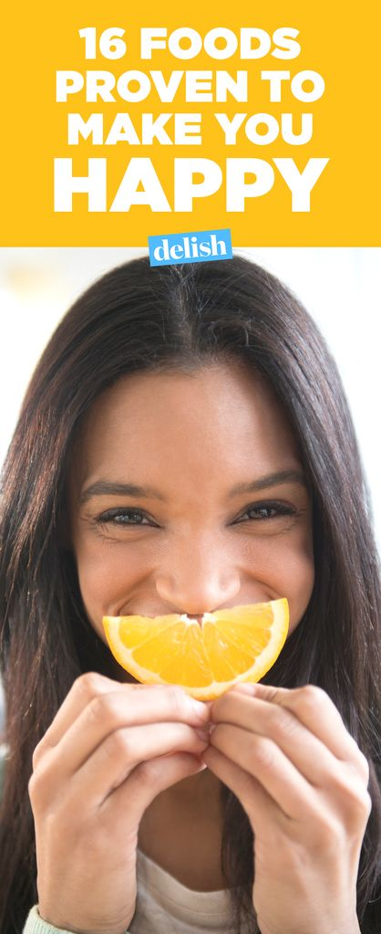

https://www.youtube.com/watch?v=o6f8tS32f6Y
Let’s find out if you have a healthy diet
https://wordwall.net/resource/45014/science/healthy-eating-quiz
So what are those healthy eating habits?
https://quizizz.com/admin/quiz/58944c86a54f2bbe4446d45d/healthy-eating-habits

