Gegužės 10 dienos pamoka
Europe Day May 9
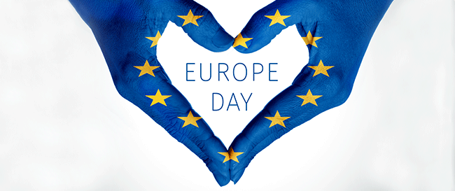

25 Interesting Facts About Europe That Most People Don’t Know
https://www.youtube.com/watch?v=3TAjPgFRiaI

Quiz: How well do you really know Europe?

https://www.wanderlust.co.uk/content/europe-trivia-quiz/

World Map Games

https://online.seterra.com/en/l/wor
World map interactive games
70 Most Populous Countries, Capitals
30 Largest Countries By Area
32 Smallest Countries By Area

French Speaking Countries
Portuguese Speaking Countries
Spanish Speaking Countries
Spanish Speaking Countries: Capitals

