Gegužės 11 dienos pamoka

TeachingEnglish Jukebox

Using songs in the English language classroom

Daniel Radcliffe - Alphabet aerobics

https://www.youtube.com/watch?v=aKdV5FvXLuI

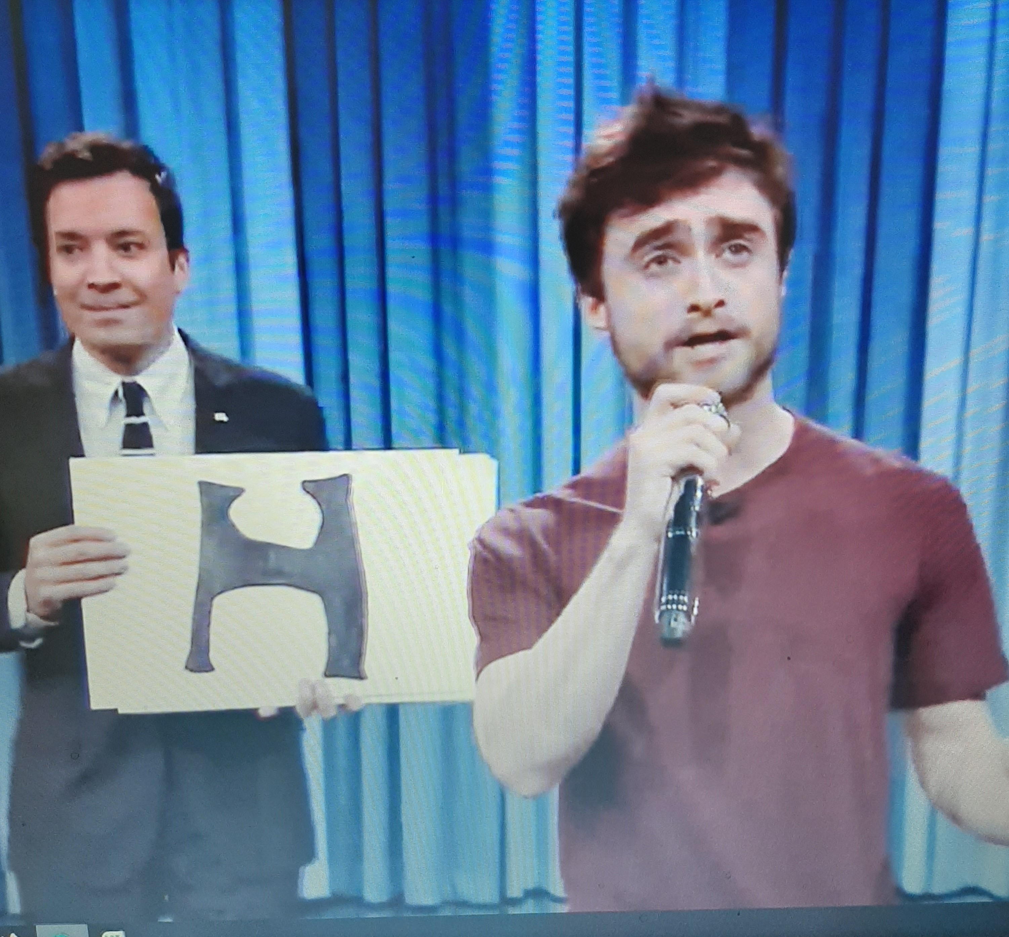

Fast car, by Jonas Blue
Different meanings of verb TO GET.
Students jot down all the expressions with GET, then replace by a synonym.
They also try to imagine the story told in the song.

https://www.youtube.com/watch?v=5yXQJBU8A28

Where or when by Michael Buble

This evergreen song is really good for revising some complex structures and reflecting on how to express feelings concerning the past and the present.

https://www.youtube.com/watch?v=VbV-_EzUgEk

