Gegužės 3 dienos pamoka
The pros and cons of having a pet

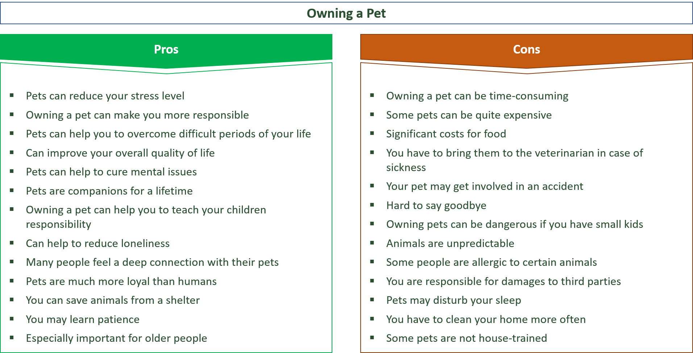

“The first advantage of “this” is …”
“There are many advantages to … and one of them is…”
“The positive aspects of … are …”
“The positive points include …”
“Another positive aspect is …”
“Another benefit is …”
“Another advantage is …”
“The benefits/ advantages are far more than the disadvantages”

“The first disadvantage of … is …..”
“There are many negative aspects and one of them is…”
“The drawbacks are…”
“The negative points include…”
“Another disadvantage is …”
“One of the major disadvantages is the fact that….”
“A negative consequence of … is …”
“The disadvantages are far more than the positive aspects in this case”

“In my opinion,”
“From my perspective,”
“In my view,”
“From my point of view,”
“Taking into account/consideration the fact that … I (firmly) believe…”
“I (strongly) agree/disagree with the view that…”

Gegužės 4 dienos pamoka
The pros and cons of zoos
