PIRATE PARTYYYYYYYY
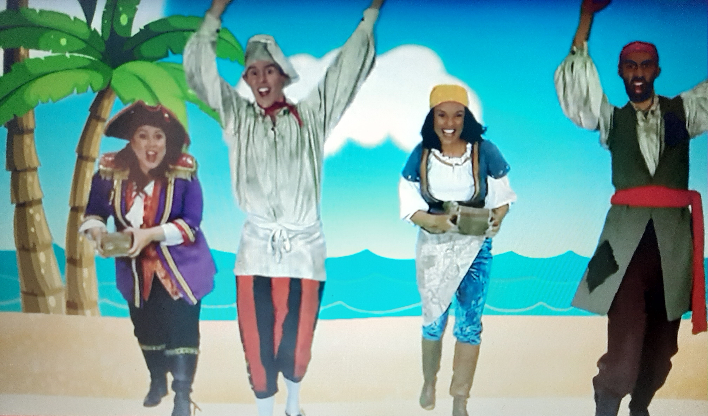

https://www.youtube.com/watch?v=jx79dLuqPwQ
https://www.youtube.com/watch?v=vRNezeciOuo

