Kovo 15 dienos pamoka
Earth Day
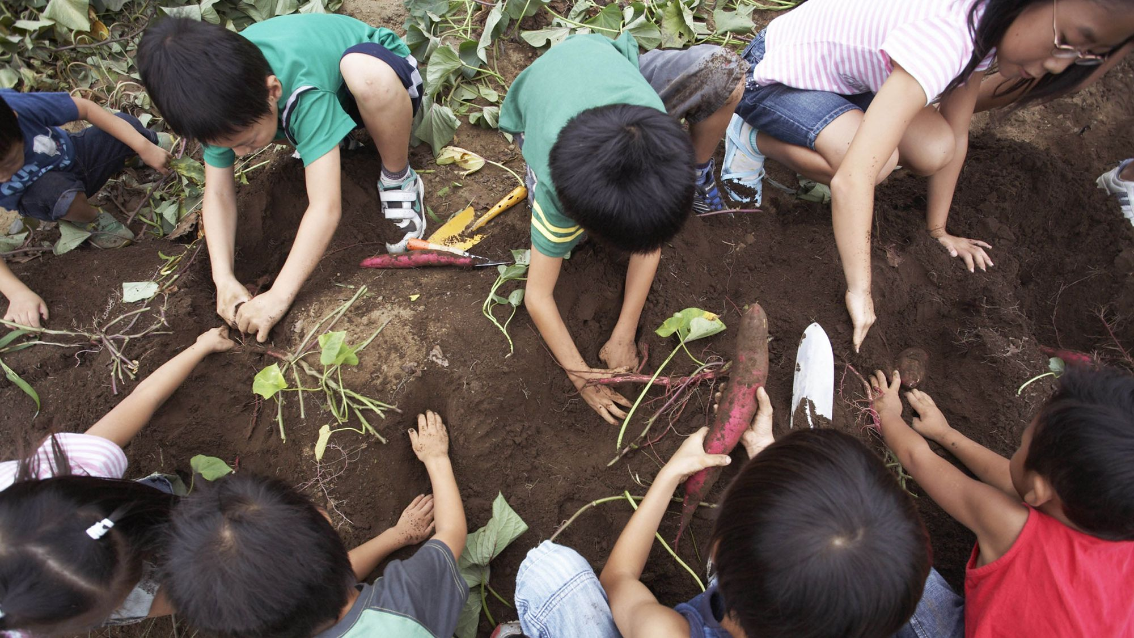

- What do you do in your life to care for the Earth?
- What do you know about the surface of the Earth?
- What are the biggest challenges facing Earth?
- Do you think it’s possible to save the Earth?
- What will happen to the Earth if all humans disappear from it?
- Have you ever used the application Google Earth?
- What do you think is the most beautiful thing about the Earth?

• Who was the founder of Earth Day? Why was the holiday started?
• What do these three words mean: reduce, reuse, recycle?
• How can people reduce their consumption of goods?
• What are non-renewable resources? How can people reduce their usage of non-renawable resources?
• List the last five items you have purchased. Which of these purchases were essential? Of the non-essential purchases, which ones have made your life easier/better/more convenient?If you had it to do over again, would you still purchase the nonessential items? Why or why not?
• What practical steps can people take to avoid purchasing non-essential items on impulse?
• Identify two ways in which you can conserve energy in each of the following areas:
- Kitchen
- Bathroom
- Bedroom
- Living room
- Classroom
• Brainstorm a list of common household items that can be reused and explain how they can be reused.
• Tell what you might do with each of the following items:
- Old clothes
- Empty jars
- Vegetable scraps
- Plastic shopping bags
- Papers printed on one side only
• What types of materials are recyclable in your community? Do you think your community has an effective recycling program in place? Why or why not?
• What steps, if any, does your local government take to encourage recycling?
• Do you recycle? If so, why? If not, why not?
• How important is it to you to buy products that can be recycled?
What is composting? How does it help protect the environment?
• How much garbage does your family generate in the average week?
• What becomes of the garbage that is collected in your neighborhood?
• What steps can you and your family take to use fewer of the earth's resources?
• List three things people can do to protect the environment.
• What other steps can you and/or your family take to make the world around you a better place?

Kovo 16 dienos pamoka
St. Patrick‘s Day
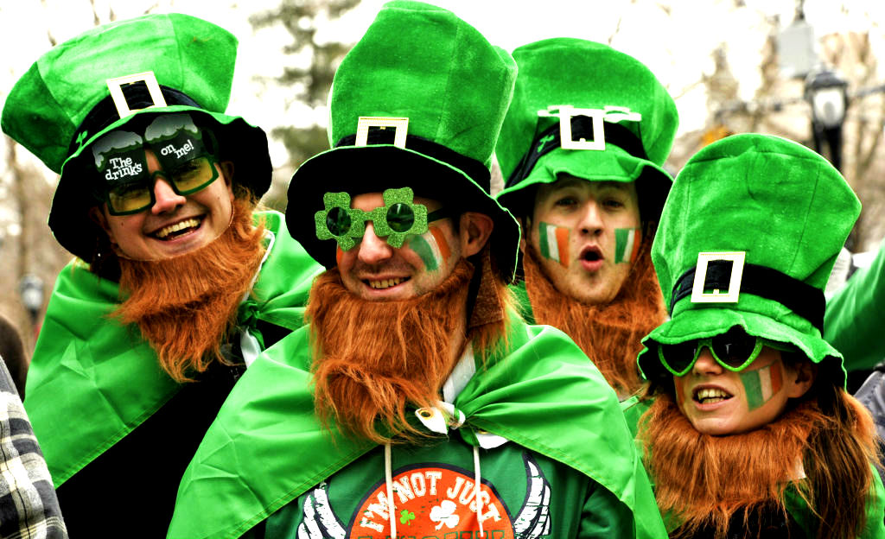

How Dublin and the world celebrate St. Patrick‘s Day
https://www.youtube.com/watch?v=py3cvo1vqSE

What‘s the origin of St. Ptarick‘s day?
https://www.youtube.com/watch?v=h5KNQ1xciMQ

Why do Irish wear green and other St. Ptrick‘s day traditions
https://www.youtube.com/watch?v=BBE_aW7Bsn4

Do we have any similar traditions in Lithuania?
How do Lithuanians celebrate this day?

