Kovo 22 dienos pamoka
How to sound polite in English?
Mandagumo formulės bendraujant anglų kalba

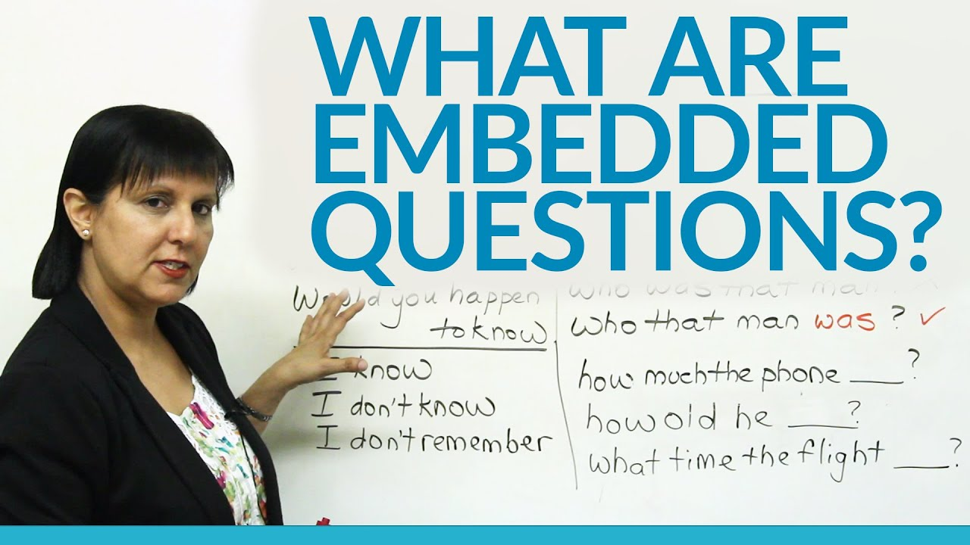

https://www.perfect-english-grammar.com/indirect-questions-exercise-1.html
https://www.usingenglish.com/quizzes/312.html
https://www.perfect-english-grammar.com/support-files/indirect-questions-exercise-1.pdf
https://www.perfect-english-grammar.com/support-files/indirect-questions-exercise-2.pdf
https://www.perfect-english-grammar.com/support-files/indirect-questions-exercise-3.pdf
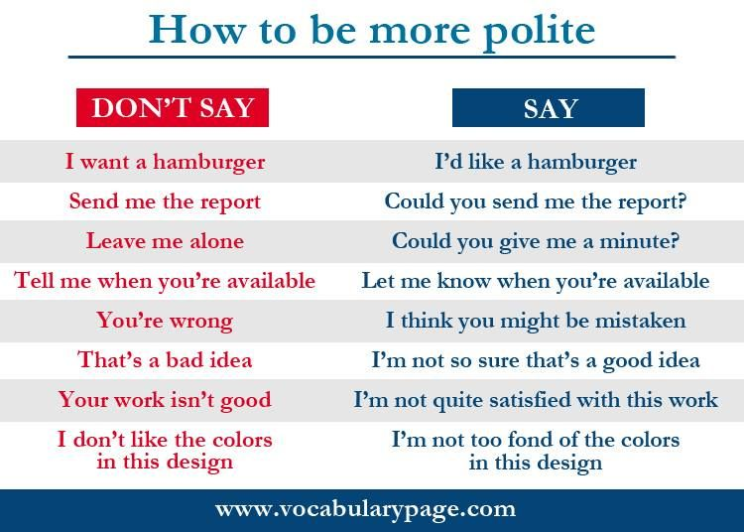

Kovo 23 dienos pamoka
Pasitikrinkime žaisdami

