Gegužės 17 dienos pamoka
What‘s for lunch in Britain?
Let us check if we know much about British cuisine

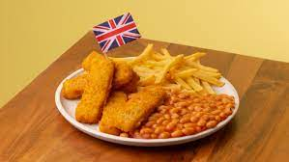

https://play.howstuffworks.com/quiz/can-you-pass-this-very-british-food-quiz

What do Brits say about their traditional foods?
https://www.youtube.com/watch?v=NnxVi4ealms
This exercise tests you on your food-related vocabulary.
Exercise instructions:
Choose the best answer for each of the following sentences:

https://speakspeak.com/english-grammar-exercises/advanced-vocabulary-exercises/food
