Birželio 1-os dienos pamoka

June 1st – International Child Defence Day
Is childhood the happiest stage of life?
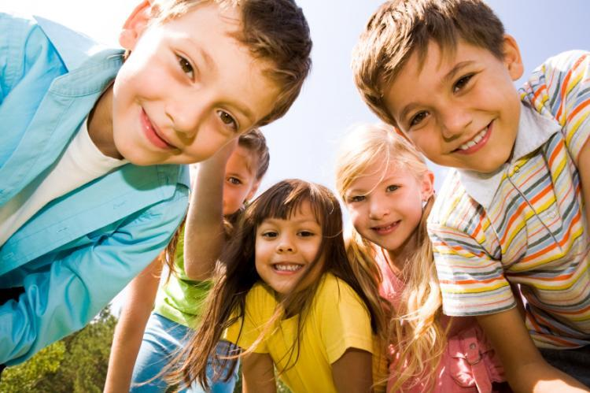
What was the best thing about your childhood?
What do you miss most about being a child?
Do you think that children these days have a better or worse childhood than your generation? Why?
What do you think is most important for a happy childhood?
What about your childhood do you wish you could change?
Where did you grow up? How did that affect your childhood?
What were some of your favorite activities when you were a child?
Who, besides your parents, had the biggest impact on your childhood?
What do you want to provide your children that you didn’t have when you were growing up?
Who were you really jealous of when you were a child? Why were you jealous?
What was your experience at school like? (elementary, junior high, or highschool)

