Birželio 2 –os dienos pamoka
Who‘s the brainiest of all?
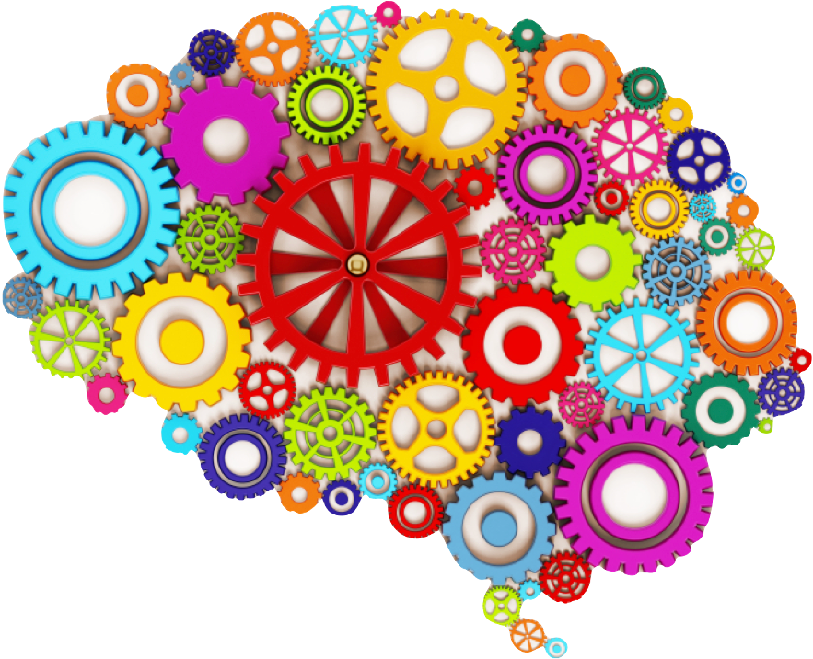
We learn while playing and solving puzzles

